Leo Chai

Mrs. Goldenburg E.

ENG4UA-04

17 March 2019

Rationale

I chose to write an online journal which investigates how the process of translating a text will change it’s meaning. The goal of my task is to demonstrate how languages are often not compatible due to their different conversions, and how people with different background interpret it.

One learning outcome of the course is understanding how language and meaning are shaped by culture and context. Specifically, for my task, I will investigate the difference between language conventions and how people of different culture background interpret texts differently.

The main audience of the text which I am writing will be people who are learning another language from a different culture background, as they need understand how people with different culture interpret language differently to translate their thoughts to another language while maintaining the same message. Specifically, I will analyze how translators change elements of a text when translating it between languages.

I will write an article published online, on Wall Street Journal. Having my text as an online journal allows me to use images and a variety of tools such as text style and spacing to organize my article. This is especially important as my journal contains text from other languages, and may become messy and hard to read if not well organized.

I chose a Chinese poem from around 800 CE and several of its English as the text that I will be analyzing. At this point in time, there will be minimal influences between the cultures, plus the two languages are from different language families. Thus, this maximizes the difference between the two languages, which helps me explain how languages may be incompatible with each other.

Word count: 278



[ART REVIEW](https://www.wsj.com/news/types/art-review)

# The Cultural Barrier between languages

Different cultures may interpret the same word differently due to references within the culture, and may create misunderstanding when communicating.

*By* *Leo Chai*

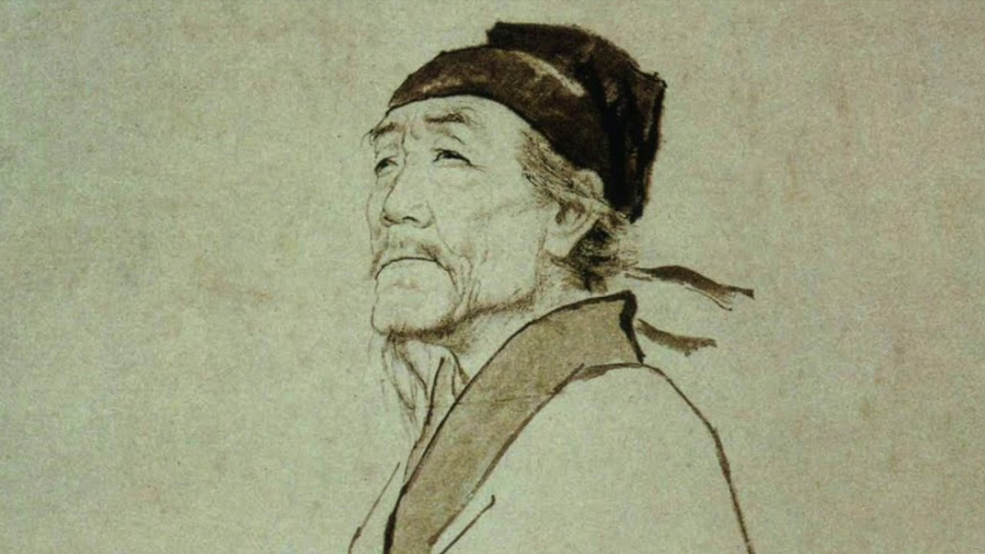March 22, 2019 2 53 p.m. ET

As the An Lushan Rebellion broke out in December 755 in China, young *Du Fu* started to travel around China in order to hide from the chaos of the war. It is this experience, that turned him into the great poet that he is,

PHOTO: DU FU (712 770), CHINESE POET significantly influencing the Chinese and Japanese literary culture even until now.

While incompatibility of different culture references is a problem especially prominent in the case of Du Fu’s poems, since his poems often feature morality and history in the context. Western readers, without proper understanding of the historical and moral context, could easily misunderstand or fail to understand the message of the poem. However, translators makes adjustments to the content and devices of the poem to allow readers to understand the poem’ better.

Here is an example of Du Fu’s poem and its translation by Kenneth Rexroth:

The original poems made several Chinese cultural references, but with changes in diction and imagery, Kenneth is able to translate the general message to the western audience:

In the second line of the first poem, Du Fu used the word "spring wind" to create an imagery of the scent of warm nature. Kenneth replaced this phrase with the term "south wind". This makes sense because winds in spring are often referred as "south wind" in America, as south is the

ORIGINAL POEM - DU FU

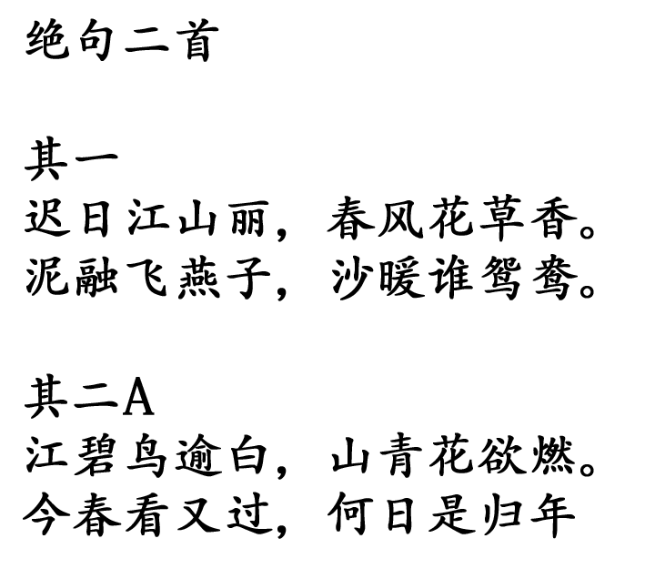

TRANSLATED POEM - KENNETH REXROTH

## South Wind

*They days frow longer, the mountains*

*Beautiful. The south wind blows*

*Over blossoming meadows*

*Newly arrived swallows dart Over the steaming marshes.*

*Ducks in pairs drowse on the warm sand.*

## Another Spring

*White birds over the grey river.*

*Scarlet flowers on the green hills. I watch the Spring go by and wonder If I shall every return home.*

direction which wind blows in spring. Furthermore, South wind have a special meaning to the native American Iroquois, for representing the warm air, smell of flowers and songs from birds. (Native American Myths and Beliefs) With the greater cultural ties of the Americans with south wind, Kenneth’s diction would be more easily recognized and understood by his American audience.

Also, in the beginning of the second poem, Du Fu created an imagery of birds fading into the river, and flaming colored flowers on mountains to create a sad atmosphere. The original poem describes the river of processing a turquoise color. However, the river is described as "grey" in Kenneth’s translation. This is because in the English culture, turquoise is often associated with livelihood and positive emotions, which instead create a positive mood. Grey blends in with white, which preserve the fading effect in the original poem. Since water are usually colored in a shade of blue, making it grey also makes the frame less colorful, thus adding successfully preserving and improving the atmosphere.

Sometimes adjustment of literary devices is able to convert unfamiliar context into familiar references, but that is not always the case. In the poem "Winter Dawn", the settings are influenced significantly by culture, and more adjustments to

the content of the poem is needed to be made in order for the western audience to completely understand the message.

Du Fu used the second and third verse displays the setting of the scene: pepper in cups of wine on a table (an ancient Chinese New Year tradition), people gathering around, with noises from horses in the stable. With the large amount of references to the Chinese culture, Western audiences would not have enough context to understand the poem. Kenneth approaches this problem by directly changing the setting to "Green wine bottles and red lobster shells" on the table. In North American culture, lobsters are seen as a sumptuous meal. The Green empty wine bottles help preserve the lively atmosphere of the party, and the lobster shells being a luxurious food demonstrates the importance of this party. Furthermore, Kenneth translated the sound of horses into "sound of cats starting", making the imagery more relatable to modern people,

since cars are far more popular than horses now. Therefore, by changing to the elements in the imagery into familiar objects, Kenneth makes the scene more relatable to the modern western audience.

Aside from Du Fu’s poems, there are many other great literary works of other languages who suffer under the same problem: not being able to be perfectly translated into another language

### PHOTO: MANDARIN DUCK

due to incompatibility of the different cultures. While this

may appear troublesome, the variety of culture is what should be celebrated, since the purpose of language is to communicate the difference in individual, groups and cultures.

ORIGINAL POEM - DU FU

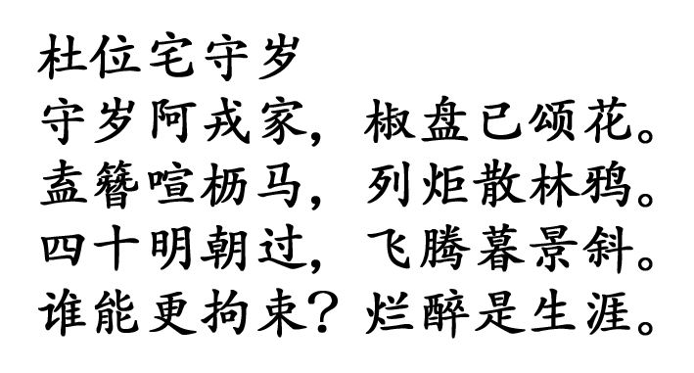

TRANSLATED POEM - KENNETH REXROTH

*—Leo Chai, professional journal writer*

## Winter Dawn

*The men and beasts of the zodiac*

*Have marched over us once more. Green wine bottles and red lobster shells, Both emptied, litter the table.*

*"Should auld acquaintance be forgot?"*

*Each*

*Sits listening to his own thoughts,*

*And the sound of cars starting outside.*

*The birds in the eaves are restless,*

*Because of the noise and light, Soon now*

*In the winter dawn I will face*

*My fortieth year. Borne headlong*

*Towards the long shadows of sunset*

*By the headstrong, stubborn moments, Life whirls past like drunken wildfire.*

Word count: 908

Work Cited

Herdan, Innes, and Yee Chiang. *300 Tang Poems = Tang Shi San Bai Shou*. Yuan Dong Tu Shu Gong Si, 2000.

Lewis, Mary Tompkins. “'Berthe Morisot, Woman Impressionist' Review: A Legacy Restored.” *The Wall Street Journal*, Dow Jones & Company, 19 Mar. 2019, www.wsj.com/articles/berthe-morisot-woman-impressionist-review-a-legacy-restored-11553021609?mod=rsswn.

Lowenstein, Tom, and Piers Vitebsky. *Native American Myths and Beliefs*. Rosen Publishing Group, 2012.

Rexroth, Kenneth. *One Hundred Poems from the Chinese*. New Directions Pub., 2013.